Project Title: Fertilizer Recommendation System for Disease Prediction Project Design Phase-I - Solution Fit Template

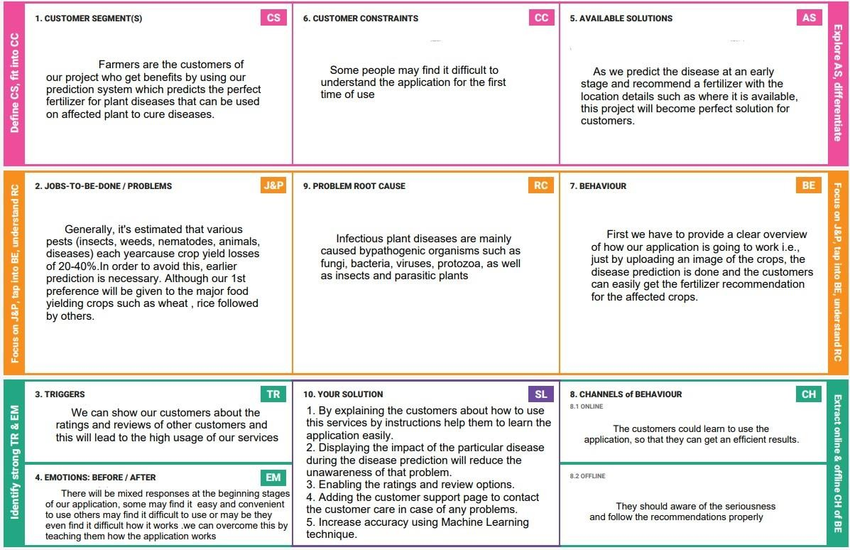Team ID : PNT2022TMID31070